Y1Q4W10

Elisha

Ask: Do you know what faith means?
Ask: If I told you that next week after Church we would be going to the beach, would you bring anything different to Church?

Say: That is what faith is. Today we are learning about a couple of women who had faith. If they hadn't had faith – and didn't believe that certain things would happen, then things would have turned out very differently.

Bible Story – Act out with pots/DVD

Sing Songs

Return to tables
Memory Verse: Fill in the blanks and then say the memory verse on the colouring page.

Primary / Junior / Teen: This term, those of you who would like to get a Bible to take home, may take one of the orange Commandment pages and add to your book. Each week you come you can put a sticker on it and when it is all complete we will get you a Bible to take home and keep.

Ask: What would have happened if the woman with the oil didn't have much faith and only borrowed a couple of jars?

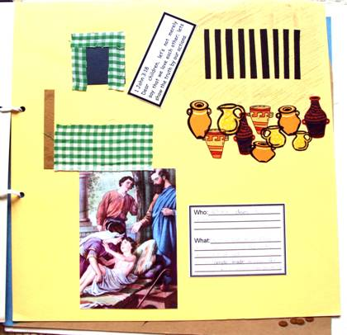
Ask: What would have happened if the woman of Shunem hadn't gone to Elisha when her son died?

Scrapbooks
- Choose a cardboard
- Stick on dark blue square and add curtains to make a window. Add a bed spread and bead head to make Elisha's room.
- Cut the black square into bars for the jail.
- Cut apart and stick on the pots
- Stick on the picture, verse and description cards.

Discuss the following depending on age, interest and time:
If I said we were going to the beach next week – why would you believe me? (Because I always tell the truth / because you know me)
Do you trust someone who you don't know?
Do you trust someone who has lied to you or been wrong in the past?
Do you trust God?
Do you know much about God? / Do you think you know God very well?
Has God ever lied or been wrong?

Optional Craft: Faith Wheel.

Say: If we don't know someone then we don't know if we can trust them.
Ask: What can we do to know God better?
Ask: Can we trust God?
Ask: What can we do to show that we trust God?

Finish with prayer.

